Lab #2 Lab Report

MIPS Assembly Programming

William Ah Tou

April 25, 2016

ECEGR 2220

Part 1:

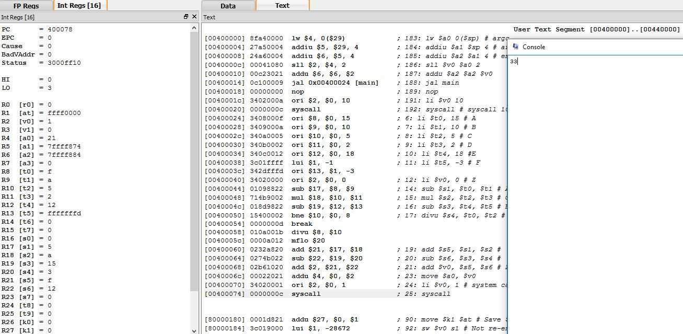QtSpim Results:

The QtSpim console results show the result to be 33, which after basic calculations can be checked and confirmed to be true. Temporary registers were used for all variables excluding Z, which was stored as a word.

Part 2:

QtSpim Results:

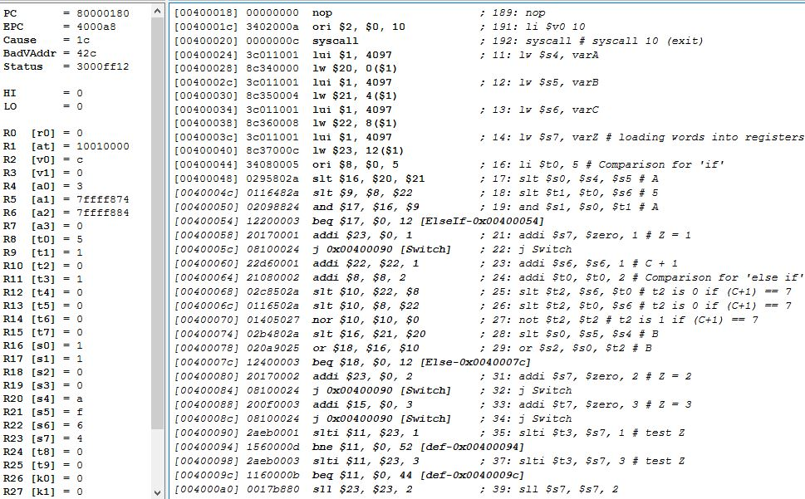

These results show that Z (register $s7) was shifted left twice which resulted in Z\*4 = 4 which is consistent with the case provided. However, as the results indicate, the switch statement is where the process gets held up. All variables given are stored as integer words but used as registers during the program.

Part 3:

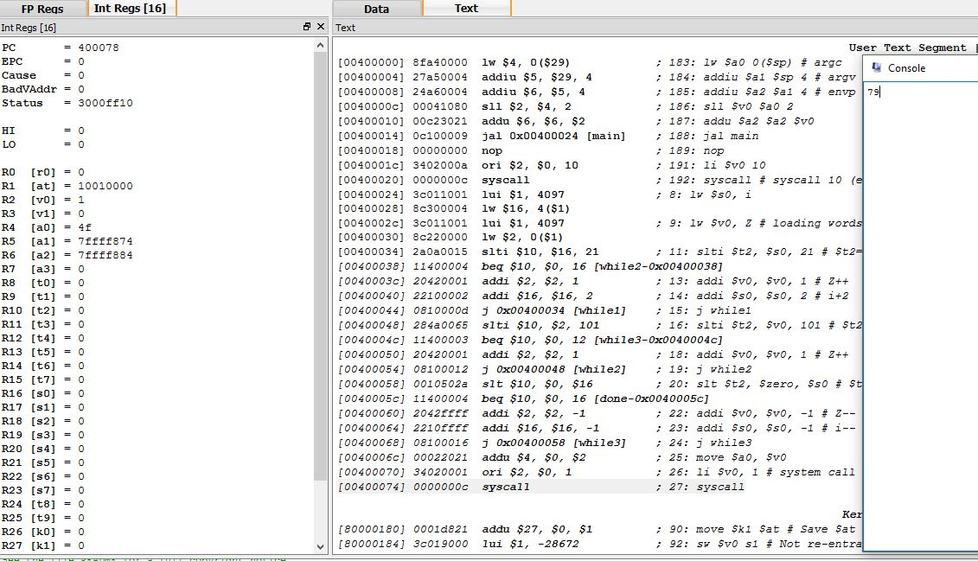QtSpim Results:

Both variables Z and I are stored as words. This program displays it is working when the variable i (register $s0) is zero and Z (register $a0) is 4f. Variable i should equal zero because the final loop terminates when i > 0 is no longer true, which occurs as i decrements to 0. At this point, Z = 79 or 4f in hex.

Part 4:

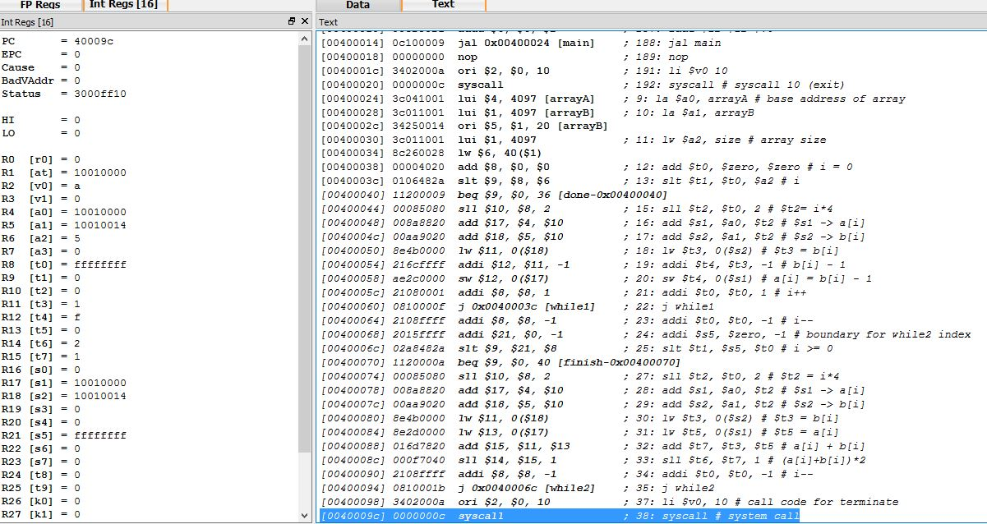QtSpim Results:

Variables A and B are stored as words while i is in a register. Both loops are written in a while loop form. The program works because the last part of the last while loop calculates the new A[1] value which should be equal to (A[1] +B[1])\*2 which in this case is (0+1)\*2 = 2, whose value is shown to be correctly calculated in register $t6.

Part 5:

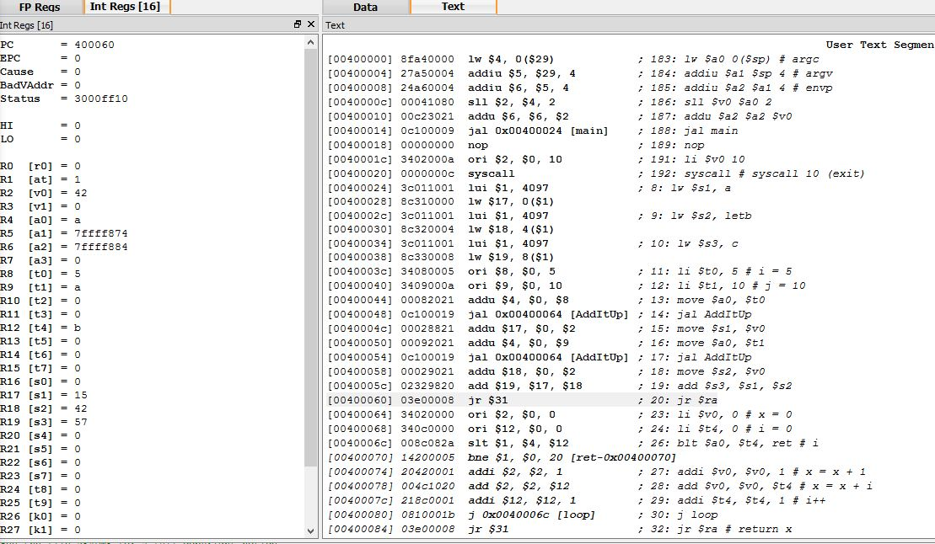QtSpim Results:

Variables A, B, C are stored as words and i and j are stored as temporary registers. This program is working as the AddItUp function correctly shows outputs in the registers $s1-3 and with $s3 being the addition of the two function outputs.